GREEN SAFE SYSTEM_EXTENSIVE HANGING GREENERY_FLOWERING MEADOW
Extensive GreenSafe Flowering Meadow hanging system got an average thickness of 13 cm/5,1 inchs and a maximum weight at maximum saturation level of 136 kg/sqm - 275,5 lb/sqm, net of flora.

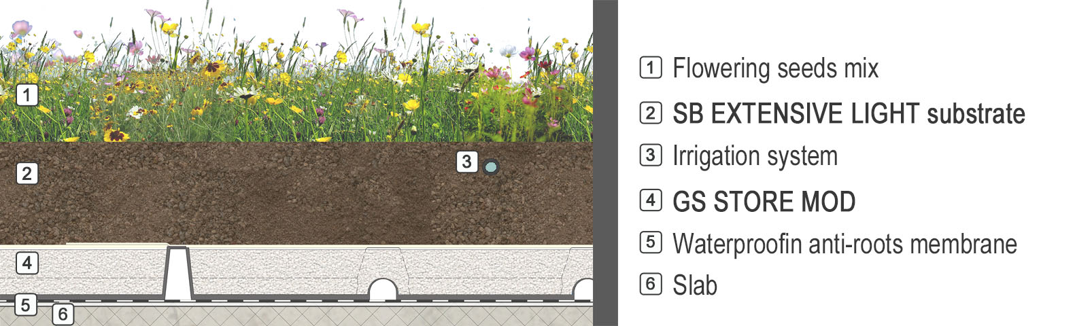

 | SPECIFICATION ITEMS
0. | LAYING SURFACE
The waterproofing system has to be leak-proof tested and roots-proof certified.
Surfaces have to be clear and clean, without any sharp edge or area, with regular gradients ( > 1%).
1. | ELEMENT OF WATER STORAGE, AERATION, DRAINAGE AND FILTERING
Modular element STORE MOD, thickness 5 cm (1,96 inches), consist of: retread non-toxic polyester felt 800 gr/sqm weight, size 600/800 mm, with mechanic protection, horizontal and vertical draining function; expanded perlite filling, size 0.1-0.2 mm, with ventilation and store&drain water function; geotextile high toughness polypropylene staple nonwoven cover element,130gr/square meter weight, with filtration and division function from the grown substrate.
Technical Features:
-Thickness: 5 cm;
-Size: 60 x 80 cm;
-pH: 6-7;
-Dry weight: 7 Kg/mq;
-Weight at maximum saturation: 35,00 Kg/m²;
-Water storage capacity: 32 l/m²;
-Storage element porosity: 95%;
-Air Volume at pF1: > 30%;
-Water Volume at pF1: >60%;
-Thermal conductivity lambda: 0.050 W/mk dry; 0.222 W/mk saturation at 100 %
All the elements got CE mark where is needed and comply with UNI11235 law.
GEO GAP and FILTRASAFE supply quantity according to levelling areas (perimeter and emerging parts).
2. | EXTENSIVE GREENING SUBSTRATE
Extensive light greening substrate consist of peat, lapillum, pumice and zeolite laid by an 8cm/3,1 inch (compaction index included) overall thickness or according agronomic needs of species planted.
Technical features:
Compaction index : 16%
-Size: 0-10 mm;
-Dry apparent volume density: 697 ± 5% kg/m³;
-Weight at potential saturation: 1144 Kg/m³; (*)
-Total porosity v/v: >60%;
-Air volume at pF1: > 15%;
-Water volume at pF1 : > 30%;
-pH: 7-8;
-Electric conductivity: < 50 mS/m;
-Cation exchange capacity > 20 meq/100g s.s;
-Organic Matter: < 60 g/l s.s;
-phytotoxicity eligible;
-Volume reduction grade under compressive strees: ≤16 %
The product comply with UNI 11235:15 law requirements

(*) Maximum saturation at pF 0,7 (UNI EN 13041:2012), Water volume at pF 0,7 > 40 %.
3. | VEGETATION
 | "Flowering Meadow " greening by the direct sown of an appropiate blend of seeds according the characteristic and the adhibition of the project area, spread on a range of 30-50 gr/sqm due intervention area.
 | "Flowering Meadow" greening by the "Hydroseeding" technology of an appropiate blend of seeds.
4. | IRRIGATION SYSTEM
Sprinkler irrigation system:
- PEAD water supply line and fittings dimensioned according pressure, flow rate and size of the hanging garden area. The water supply predisposition is up to the client.
- 9V sump battery control unit, adequately dimensioned.
- Distribution mainfold consists of an adequate number and size of 9v bistable solenoid valves, relating irrigation casing sumps and fittings.
- PEBD Main supply lines dimensioned according pressure, flow rate and size of the hanging garden area.
- Rotary and/or Fixed sprinklers to the lawn areas and eventual dripping wing to the schrubs/trees areas, according project (including fittings).
- Rain sensor.
Sub-irrigation system consist of a pre-drilled anti-roots 16mm diametr pipe, divided into appropiate areas controlled by 1” 9V bistable solenoid valves and 9V battery control unit, including everything necessary to guarantee the hand-over and acceptance test. (excluding water supply predisposition, which is up to the client).
5. | HANGING SYSTEMS ACCESSORIES
 | Inspection drainage concrete sumps, color grey, size 20x20cm, including h 5 cm traps and draining extension in order to achieve hanging package project height.

