GREEN SAFE SYSTEM_EXTENSIVE HANGING GREENERY – SLOPE
The extensive GreenSafe sedum slope hanging system got an average thickness of 13 cm/5,1 inchs and a maximum weight at maximum saturation level of 145 kg/sqm - 319 lb/sqm, net of flora.
This system permits the installation of hanging greenery on sloped surfaces up to 45° of rake angle.
NB: It is always appropiate to provide for an anchorage point of the hanging system at the top of the slope.

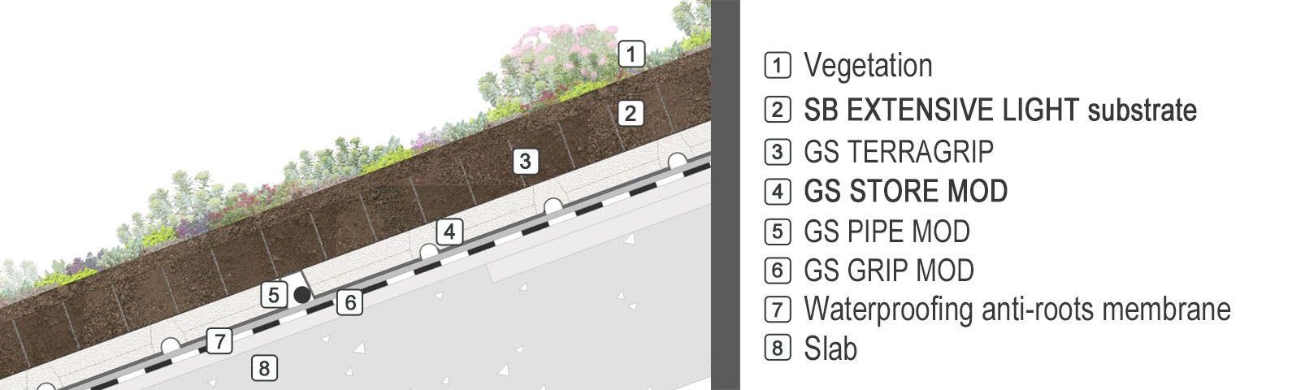
 | SPECIFICATION ITEMS
0. | LAYING SURFACE
 | The waterproofing system has to be leak-proof tested and roots-proof certified.
1. | ELEMENT OF STABILISATION AND STRENGTHENING: GS GRIPMOD
 | Bidimensional full junture Geogrid, made of 100% heavy duty polyethilene with high mechanical and tensional resistance, designed to provide restraint and stability to the slope hanging system all.
2. | ELEMENT OF ANCHORING: GS PIPE MOD
 | Anchoring element made of polyethilene hard pipes, diameter 32m, fixed to the stabilizer element, in order to restraint the stratigraphy by the use of high density heavy duty polyethilene zip ties, which are heavy load and wear-proof.
3. | ELEMENT OF WATER STORAGE, AERATION, DRAINAGE AND FILTERING
Modular element STORE MOD, thickness 5 cm (1,96 inches), consist of: retread non-toxic polyester felt 800 gr/sqm weight, size 600/800 mm, with mechanic protection, horizontal and vertical draining function; expanded perlite filling, size 0.1-0.2 mm, with ventilation and store&drain water function; geotextile high toughness polypropylene staple nonwoven cover element,130gr/square meter weight, with filtration and division function from the grown substrate.
Technical Features:
-Thickness: 5 cm;
-Size: 60 x 80 cm;
-pH: 6-7;
-Dry weight: 7 Kg/mq;
-Weight at maximum saturation: 35,00 Kg/m²;
-Water storage capacity: 32 l/m²;
-Storage element porosity: 95%;
-Air Volume at pF1: > 30%;
-Water Volume at pF1: >60%;
-Thermal conductivity lambda: 0.050 W/mk dry; 0.222 W/mk saturation at 100 %
All the elements got CE mark where is needed and comply with UNI11235 law.
GEO GAP and FILTRASAFE supply quantity according to levelling areas (perimeter and emerging parts).
-Conducibilità termica λ: 0,050W/mk a secco; 0,222 W/mk al 100% di saturazione.
Tutti gli elementi sono marcati CE ove prescritto e rispondono alla norma UNI11235.
Fornitura di Geo Gap e FiltraSafe in quantità adeguata alla compensazione delle prossimità di eventuali perimetri irregolari e corpi emergenti.
4. | ELEMENT OF RESTRAINT AND EROSION-PREVENT: GS TERRAGRIP
 | Restraint element consists of panels made by high density polyethylene cells, 75 mm thickness, which form a restraint 3D alveolar structure to confine the cultivation substrate.
5. | EXTENSIVE GREENING SUBSTRATE
Extensive light greening substrate consist of peat, lapillum, pumice and zeolite laid by an 8 cm/ 3,1 inch (compaction index included) overall thickness or according agronomic needs of species planted.
Technical features:
Compaction index : 16%
-Size: 0-10 mm;
-Dry apparent volume density: 697 ± 5% kg/m³;
-Weight at potential saturation: 1144 Kg/m³; (*)
-Total porosity v/v: >60%;
-Air volume at pF1: > 15%;
-Water volume at pF1 : > 30%;
-pH: 7-8;
-Electric conductivity: < 50 mS/m;
-Cation exchange capacity > 20 meq/100g s.s;
-Organic Matter: < 60 g/l s.s;
-phytotoxicity eligible;
-Volume reduction grade under compressive strees: ≤16 %
The product comply with UNI 11235:15 law requirements

(*) Maximum saturation at pF 0,7 (UNI EN 13041:2012), Water volume at pF 0,7 > 40 %.
6. | VEGETATION
Sedum graftable
greening by Crussulacee species like Sedum spp., broadcast sown with a 4 (at least) different species blend e distribuited 80gr/sqm - 3oz/sqm

N.B. Sedum supply could be subjected to seasonal matters , sowing coulb be delayed compered to system laying according weather conditions.
Sedum Rolls
Sedum rolls greening, made by the cultivation of different species of sedum on a biodegradable pre-vegetated mat, with the aim to get a 90% of surface cover at laying time.
Sedum pots
greening by Crussulacee species like Sedum spp, 7x7 pots.
7. | IRRIGATION SYSTEM
 | Sub-irrigation system consist of a pre-drilled anti-roots 16mm diametr pipe, divided into appropiate areas controlled by 1” 9V bistable solenoid valves and 9V battery control unit, including everything necessary to guarantee the hand-over and acceptance test. (excluding water supply predisposition, which is up to the client).

